**Final Assignment Instructions: Create and Share Your Jupyter Notebook**

Module6

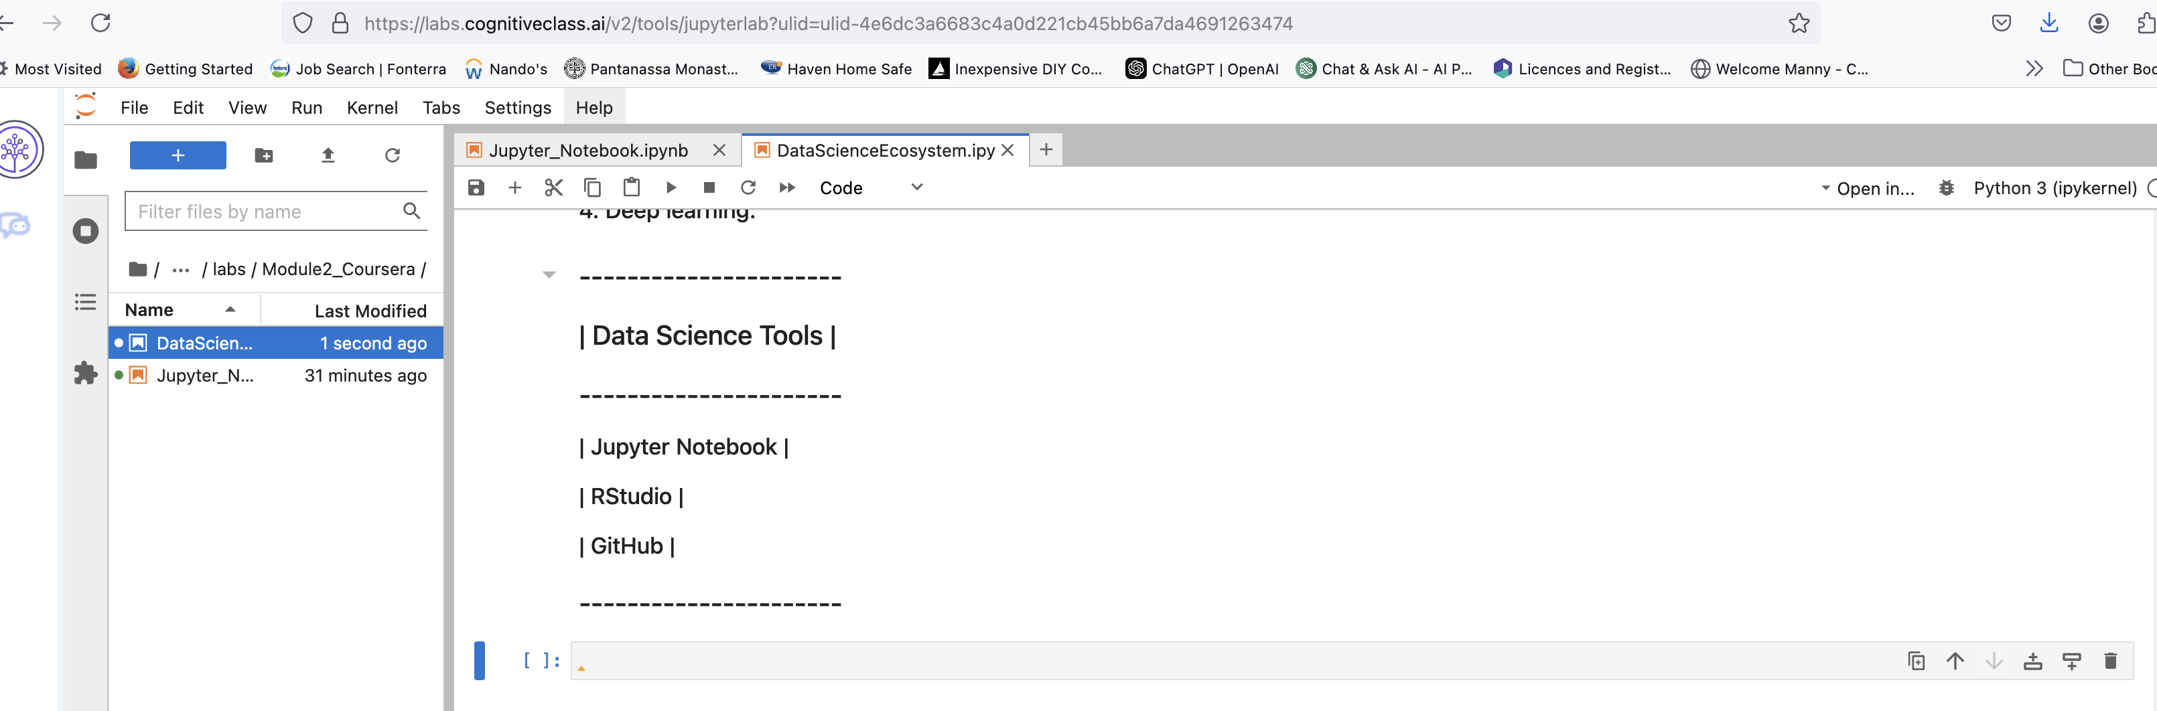

https://github.com/MannyK70/Jupyter-Notebooks-Assignment-EK/commit/3765354af52b6a12e474b40e43eb60dd2f0f7f46